
The worklist feature in Vault Professional is a nice feature. It pops up information informing you of any change orders you need to take action on. The only problem is that you need to launch the Vault Professional client. Chris Sawicki and Brian Schanen decided to change that with Vault Gadget.
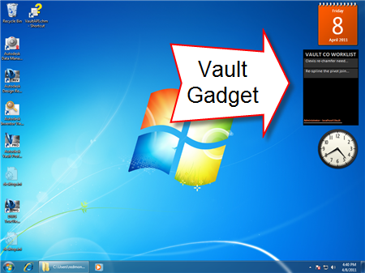
(click image for full view)
Vault Gadget allows you to view your worklist from your desktop, without the need to run Vault Professional.
Requirements:
- Vault Professional 2012
Click here to download
To use:
- Extract the contents of the ZIP file to “%localappdata%\Microsoft\Windows Sidebar\Gadgets”. The result of this step is a folder named VaultCO.Gadget in the “%localappdata%\Microsoft\Windows Sidebar\Gadgets” folder.
- Right-click on the desktop and select the “Gadgets” menu item. The Gadget Gallery will be displayed.
Features:
- See the change orders in your worklist without running Vault Professional.
- Refresh timer - adjust how often Vault Gadget checks for worklist items.
- Click on a change order to view the properties.
- Click on the "Go To CO" link to launch Vault Professional and navigate to the Change Order.
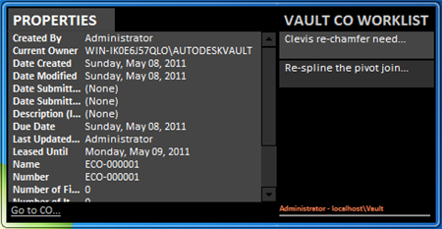
Source Code:
Vault Gadget is a set of HTML pages with embedded javascript. So the application is the source code. Just use an HTML editor to see what is going on. Communication with the Vault Server is very low level in this example. The javascript is creating and parsing the raw XML.
As with all the samples on this site, the legal disclaimer applies.
4 weeks have passed and, as promised, 4 apps have been posted. Special thanks to all the members of the Vault team that submitted apps. We now return you to your regular Vault API blog.

